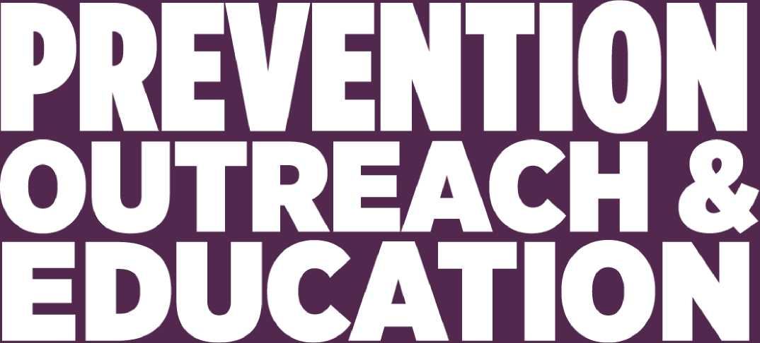

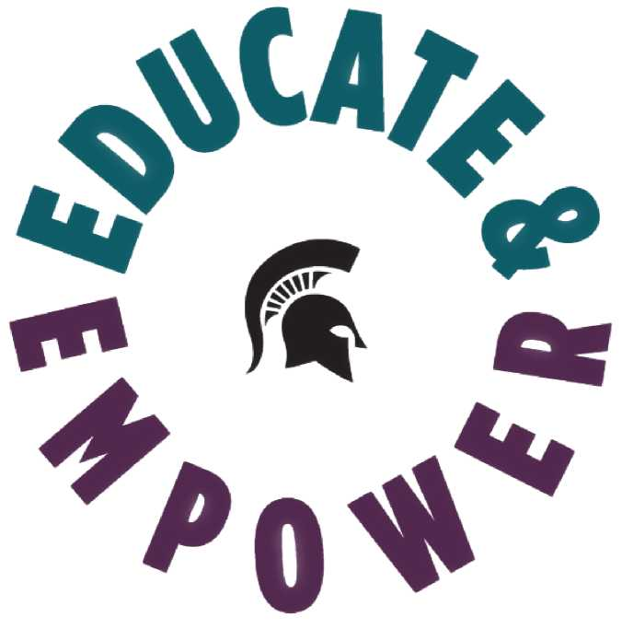

2020-2021 ANNUAL REPORT

Table of Contents
LETTER FROM THE EXECUTIVE DIRECTOR 4
DEPARTMENT MISSION & FOCUS 5
Focus Areas: 5
Educate the University Community 5
6
Eliminate Gender-Based Violence 6
Affect Positive Social Change 6
7
UNDERGRADUATE STUDENT PROGRAMMING 7
8
SEXUAL ASSUALT & RELATIONSHIP VIOLENCE PREVENTION WORKSHOP 8
SARV PREVENTION FOLLOW UP 9
10
BYSTANDER NETWORK WORKSHOP 10
ONLINE UNDERGRADUATE TRAINING 12
GREEKS TAKE THE LEAD 13
SPARTANS AGAINST VIOLENCE 15
SPARTANS AGAINST VIOLENCE DATA 16
PEER EDUCATOR PROGRAM 17
POE SCHOLARSHIP 17
POE PEER MENTOR 17
Pilot Program 17
Student Voices for Prevention Initiatives Advisory Council 18
Student Voices for Prevention Initiatives (SVPI) 18
Student Organization & Units Represented in SVPI in Spring 2021: 18
FACULTY, STAFF, GRADUATE STUDENTS, AND POSTDOCTORAL EDUCATION 19
Online Employee & Graduate Student Education 19
ONLINE GRADUATE STUDENT TRAINING 20
POE SECOND ANNUAL SUMMIT 20
Participant experiences captured in Post-Survey: 20
21
MSU HEALTH CARE EDUCATION 21
Training includes: 21
CLIMATE & RESPONSE ENGAGEMENT 22
Reflections from constituents regarding this process: 23
UNIVERSITY & COMMUNITY IMPACT 24
IT’S ON US WEEK OF ACTION 25
27
COMMUNITY PROGRAMMING 27
Active BARstander 27
Strengthening Safety 27
STAFF ENGAGEMENT IN COMMITTEE & WORKSHOP 28
PEER EDUCATOR LONGEVITY DATA 29
PEER EDUCATOR LONGEVITY SURVEY REFLECTIONS 30
FUTURE GROWTH & DEVELOPMENT 31
(1) MEN'S ENGAGEMENT PROGRAM: 31
(2) EMPOWERMENT SERIES: 31
(3) NASPA CULTURE OF RESPECT: 31

LETTER FROM THE EXECUTIVE DIRECTOR

Spartan Community,
It is with profound gratitude that I present the 2020/2021 Prevention, Outreach and Education Department's annual report. This year has been full of challenges and opportunities for creative thinking about how we can support one another and still empower people without being in the same room. I am inspired by the different way the POE team and university community has come together to support one another during these difficult times.

The POE team delivers a tremendous amount of in-person and online learning opportunities. Despite working remotely, we managed the time-consuming process of moving all our programming into virtual formats while keeping our personalized “live” components that make our training so dynamic. Our Peer Educator team of undergraduate students went above and beyond expectations by training online, supporting one another and learning how to run virtual sessions to make our students' learning experience personalized and supportive. This year has been exceedingly stressful for staff and students alike. Their dedication to ending sexual and relationship violence at MSU is extremely inspiring.

During this year, the POE team also took time to restructure our department, adding an Assistant Director over undergraduate programming and engagement as well as promoting the Climate and Response Specialist to a Climate and Response Program Administrator to build on the groundbreaking work being done across our campus. In addition, we worked to hone our mission and vision statements, align our learning outcomes and evaluations to improve the impact of prevention education for all university community members.

I look forward to continuing to lead our team of innovative staff and students in the upcoming year.

Kelly Schweda (she, her, hers)
Executive Director
Prevention, Outreach and Education Department 8

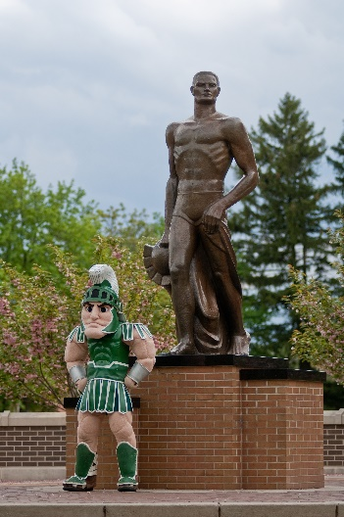

DEPARTMENT MISSION & FOCUS

“Empowering community commitment to prevent gender-based violence through education, outreach and social change."

  - Focus Areas:
- Educate the University
- Eliminate Gender-Based Violence
- After Positive Social Change

Educate the University Community

The Prevention, Outreach and Education (POE) Department engages members of the university community by utilizing multi-disciplinary, community-driven and trauma-informed approaches to educating on the prevention of gender-based violence.
Examples of these efforts include:

- Upholding, exceeding, and developing best practice models for prevention.
- Providing required prevention training and requested advanced topic training for faculty and staff across the university.
- Innovative programming and educational initiatives for undergraduate and graduate students in multiple learning formats.
- Creating specialized Relationship Violence and Sexual Misconduct (RVSM) prevention training for MSU Health Care to ensure the safety of faculty, staff, students, and patients.
- Developing, facilitating, and engaging with community-specific workshops, programs, and initiatives.
Eliminate Gender-Based Violence
The Prevention, Outreach and Education Department serves as a catalyst to mobilize personal responsibility and leadership to end gender-based violence. POE builds coalitions and partnerships across the university by engaging a broad range of constituents to take action. We empower staff, faculty and students to become advocates for change, support survivors, and shift the climate at MSU and in our communities.
Examples of these efforts include:
- Raising awareness on navigating the MSU RVSM & Title IX policy and obligations, and support survivors during disclosures.
- Collaborating and engaging with university and community partners through membership in strategic planning groups, leadership initiatives and task forces focused on tangible outcomes.
- Creating opportunities for students to engage in developing, facilitating, and improving prevention initiatives across the university community.
- Uplifting the potential impacts of gender-based violence rooted in systems of power and privilege to deepen university community understanding [of this type of violence].

Affect Positive Social Change
The Prevention, Outreach and Education Department initiates efforts and takes action at the interpersonal, institutional and systemic levels to effectively impact social change. Through educating and empowering the university community, POE strives to create an environment that shifts attitudes, beliefs, behaviors, and norms to transform our climate and culture.
Examples of these efforts include:
- Providing advanced learning opportunities for faculty and staff to engage as a community around topics of gender-based violence.
- Addressing the impact of gender-based violence within units to develop pathways for positive change and prevent future harm from occurring.
- Collaboratively identifying university wide needs through hosting listening sessions, training and interventions based on trends across units and the university.
- Creating opportunities for students to gain more knowledge and be leaders within the university community and become global agents of change.
- Continuous training and collaborating with partners in the field.

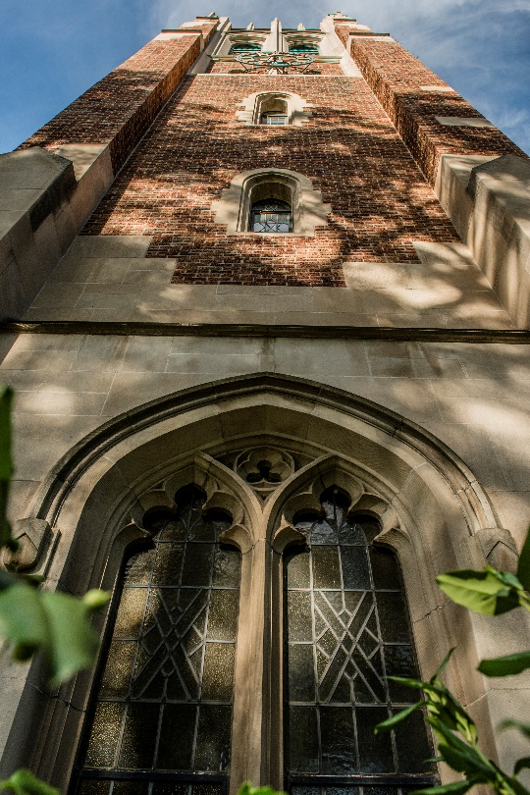

UNDERGRADUATE STUDENT PROGRAMMING

This year undergraduate student programming and engagement was restructured and expanded to include an assistant director. With the creation of this position, the current student prevention services unit includes the assistant director, three prevention specialists, a peer educator coordinator, and the front desk professional staff person for clerical support. This unit is responsible for the creation, delivery, and assessment of all undergraduate student programs, in natives, collaborations, and partnerships. In this section of the annual report, each of the current undergraduate initiatives and programs will be highlighted. In addition, it is important to note that all the evaluative elements for undergraduate student programming were reviewed and redesigned in the summer of 2020. With this new assessment redesign, all evaluations were streamlined based on the work to align with one another and to the Know More campus climate survey data.

Programs and initiatives in this unit include the following: Sexual Assault & Relationship Violence Prevention Workshop, Bystander Network, Spartans Against Violence, Greeks Take the Lead, the Peer Educator & Peer Mentor programs, Student Voices for Prevention Initiatives Advisory Council, Strengthening Safety, Active BARStander and the It's On Us Week of Action.

SEXUAL ASSUALT & RELATIONSHIP VIOLENCE PREVENTION WORKSHOP

The Sexual Assault and Relationship Violence (SARV) Prevention workshop is an education-based learning experience that is required for undergraduate students in their first year (freshmen and new transfer students) at MSU. The SARV Prevention workshop defines gender-based violence explains university policies and reviews survivor-centered resources available on campus and in the community.

This workshop defines the terms within university policy and discusses ways to intervene and begin changing the culture to help create a violence-free community. Some workshops provide more expanded support and information to LBGTQA+ and International student communities.

9,373
Students Served
489
Workshops Facilitated

The most common drug used to facilitate sexual assault is alcohol. Prior to
attending the workshop 68% of participants said that they either strongly agreed or agreed to this statement, with 14% saying they strongly agreed. After the workshop, 81% of the participants said they strongly agreed and agreed, with 38% saying they strongly agree.

Consent for sex can be withdrawn at any time during or before an act of sexual activity. Prior to attending the workshop 91 % of participants said that they either strongly agreed or agreed to this statement, with 68% saying they strongly agreed. After the workshop, 95% of the participants said they strongly agreed and agreed, with 78% saying they strongly agreed.

People seeking medical attention are protected even if they consumed alcohol or other drugs. Prior to attending the workshop 76% of participants said that they either strongly agreed or agreed to this statement, with 34% saying they strongly agreed. After the workshop, 89% of the participants said they strongly agreed and agreed, with 59% saying they strongly agreed.

I think there is much I can do about sexual misconduct on campus. Prior to attending the workshop 47% of participants said that they either strongly agreed or agreed to this statement, with 8% saying they strongly agreed. After the workshop, 77% of the participants said they strongly agreed and agreed, with 25% saying they strongly agreed.

I think there is much I can do about relationship violence on campus. Prior to attending the workshop 46% of participants said that they either strongly agreed or agreed to this statement, with 7% saying they strongly agreed. After the workshop, 76% of the participants said they strongly agreed and agreed, with 25% saying they strongly agreed.

- Develop a plan for ways I might safely intervene as a bystander. Prior to attending the workshop 83% of participants said that they were very likely or likely to engage in the behavior, with 30% saying they strongly agreed. After the workshop, 93% of the participants said they were very likely or likely to engage in this behavior, with 53% saying they were very likely to engage in this behavior.
- Ask someone who seems upset if they are okay or need help. Prior to attending the workshop 91% of participants said that they were very likely or likely to engage in the behavior, with 48% saying they strongly agree After the workshop 95% of the participants said they were very likely or likely to engage in this behavior, with 62% saying they were very likely to engage in this behavior.
- Talk to a friend who seems to be pressuring their partner. Prior to attending the workshop 90% of participants said that they were very likely or likely to engage in the behavior, with 45% saying they strongly agreed. After the workshop, 95% of the participants said they were very likely or likely to engage in this behavior, with 60% saying they were very likely to engage in this behavior.
- Connect a friend with someone (counselor, advocate, etc.). Prior to attending the workshop 82% of participants said that they were very likely or likely to engage in the behavior, with 37% saying they strongly agreed. After the workshop, 91% of the participants said they were very likely or likely to engage in this behavior, with 54% saying they were very likely to engage in this behavior.
- Say something when I hear someone make a negative comment about someone. Prior to attending the workshop 87% of participants said that they were very likely or likely to engage in the behavior, with 42% saying they strongly agreed. After the workshop, 92% of the participants said they were very likely or likely to engage in this behavior, with 56% saying they were very likely to engage in this behavior.

SARV PREVENTION FOLLOW UP

First-year and transfer students who attended their SARV Prevention Workshop in 2020-2021 were sent a follow-up survey in April 2021 to assess their retention and application of the content since attending their workshop.

- “I learned about a lot of things that are considered abusive that I didn't think of before.”
- “MSU is very supportive in this aspect and has resources for help.
- “You can make a difference if you intervene.”
- “The red flags mentioned in the SARV workshop apply to family & friend relationships as
- “I appreciate that this SARV [prevention workshop] was required, I think more people need to take these issues seriously and be educated about them.”
- “I learned about a lot of things that are considered abusive that I didn’t think of before.”
- I can help to prevent something even if it can’t physically intervene.”

BYSTANDER NETWORK WORKSHOP

This workshop is required for all second-year students and explores the ways that all students can be active bystanders and delve deeper into what bystander entails. Topics of supporting survivors and holding each other are also explored in-depth during this workshop. Three major components of participant learning were assessed via pre and post evaluations: Knowledge, RVSM Attitudes and Behaviors.

- There are multiple ways for someone to intervene in potential acts of violence. Prior to attending the workshop 93% of participants said that they either strongly agreed or agreed to this statement, with 52% saying they strongly agreed. After the workshop, 95% of the participants said they strongly agreed and agreed, with 69% saying they strongly agreed.
- If someone doesn't know how to help, they can ask someone else to do it. Prior to attending the workshop 81 % of participants said that they either strongly agreed or agreed to this statement, with 31 % saying they strongly agreed. After the workshop, 91% of the participants said they strongly agreed and agreed, with 56% saying they strongly agreed

RVSM Attitudes:

- I think there is much I can do about sexual misconduct on campus. Prior to attending the workshop 44% of participants said that they either strongly agreed or agreed to this statement, with 9% saying they strongly agreed. After the workshop, 75% of the participants said they strongly agreed and agreed, with 29% saying they strongly agreed.
- I think there is much I can do about relationship violence on campus. Prior to attending the workshop 42% of participants said that they either strongly agreed or agreed to this statement, with 8% saying they strongly agreed. After the workshop, 74% of the participants said they strongly agreed and agreed, with 28% saying they strongly agree.
BYSTANDER NETWORK WORKSHOP

- Develop a plan for ways I might safely intervene as a bystander if I see potential abuse happening around me. Prior to attending the workshop 79% of participants said that they were very likely or likely to engage in the behavior, with 26% saying they were very likely to engage. After the workshop, 91% of the participants said they were very likely or likely to engage in this behavior, with 50% saying they were very likely to engage in this behavior.
- Ask someone who seems upset if they are okay or need help. Prior to attending the workshop 89% of participants said that they were very likely or likely to engage in the behavior, with 46% saying they strongly agreed. After the workshop, 94% of the participants said they were very likely or likely to engage in this behavior, with 61% saying they were very likely to engage in this behavior.
- Talk to a friend who seems to be pressuring their partner to do things their partner does not want to do. Prior to attending the workshop 88% of participants said that they were very likely or likely to engage in the behavior with 42% saying they strongly agreed. After the workshop, 93% of the participants said they were very likely or likely to engage in this behavior, with 59% saying they were very likely to engage in this behavior.
- Connect a friend with someone (e.g. counselor, advocate, support person) to talk about an unwanted sexual experience. Prior to attending the workshop 81% of participants said that they were very likely or likely to engage in the behavior, with 35% saying they strongly agreed. After the workshop, 90% of the participants said they were very likely or likely to engage in this behavior, with 54% saying they were very likely to engage.
- Say something when I hear someone making a negative comment about someone who has been impacted by sexual violence. Prior to attending the workshop 85% of participants said that they were very likely or likely to engage in the behavior, with 40% saying they strongly agreed. After the workshop, 92% of the participants said they were very likely or likely to engage in this behavior, with 56% saying they were very likely to engage in this behavior.

ONLINE UNDERGRADUATE TRAINING

MSU undergraduates who have successfully completed in-person training the past two years are assigned to an online refresher for the 2020-21 academic year. These students are in their third and fourth years on campus. A total of 15,169 undergraduate students participated in the online session.

The data shows student knowledge before and after their participation in the online refresher workshop.

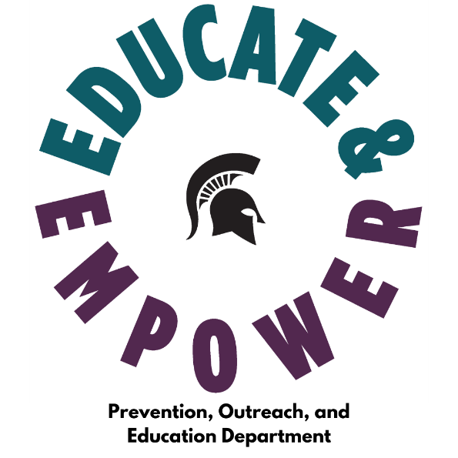

GREEKS TAKE THE LEAD

The Greeks Take the Lead (GTTL) Program is a workshop series required for all fraternity and sorority chapters that are currently registered student organizations (RSOs) or are hoping to become an RSO. The Greeks Take the Lead Program serves to support and empower the fraternity and sorority students by providing further education on how they can intervene and end gender-based violence in their chapters and the greater community.

All chapter presidents and risk managers (or another leadership member, if a chapter does not have a risk manager) participate in a leadership-based interactive training, and all general members attend a workshop focused on a specialized topic of their choice. Individual chapters and councils were also encouraged to reach out to organize individualized workshops focused on a topic of interest. 2,910 students attended various training.

Interfraternity Council (IFC) | 51%
Multicultural Greek Council (MGC) | 70%
National Panhellenic Council (NPHC) | 59%
Panhellenic Council (PC) | 69%
Fraternity & Sorority Life (FSL) Total | 60%

MSU Center for Survivors | Supporting Survivors in Fraternity & Sorority Life | Wed. Feb 3  5:30 - 6:30 PM
Chelsea Gifford ΑΣΑ | Bystander Intervention and Personal Accountability | Tues. Feb 9  6 - 7 PM
MSU POE Prevention Specialist | The Big ‘C’: Promoting a Culture of Consent | Thurs. Feb 18  7 - 8 PM
Keynote: Zeke Thomas ΖΒΤ | Survivors Become Thrivers: How I am Healing Physical & Mental Trauma to Achieve My Goals | Tues. Feb 23  7 - 8 PM
Alex Dudek ΠΚΦ | Title IX and You: Implications for Fraternities and Sororities | Wed. Mar 10  7 - 8 PM
Ana Sanz-Saumeth ΣΛΓ | Racial Identity and Violence: The Experiences of an Intersectional Identity | Mon. Mar 15  6 - 7 PM
Sharalle Arnold ΣΓΡ | Relationships: Considerations when Picking Him, Her, or Them | Tues. Mar 23  6:30 – 7:30 PM

NPHC fraternity member who attended “Racial Identity and Violence: The Experiences of an
Intersectional Identity” said: “This session helped me become more comfortable as a person with a voice to speak on sensitive topics such as this. This will help me become a better ally to my friends when these conversations present themselves.”
- An IFC fraternity member who attended “Title IX and You” reflected: “The thing that I recognized most as being a change that I should enact in my life is that I ought to curb my use of language that could be insensitive towards those who have experienced some form of trauma. While I do avoid the word rape, some of my jokes and wording can often have implications that I might find humorous, but others may be harmed by.”
- A Panhellenic sorority member who attended “Supporting Survivors in Fraternity & Sorority Life”: “The way you respond can be beneficial because it allows us to understand and show empathy while being supportive.”
- An MGC sorority member who attended “Bystander Intervention and Personal Accountability” said: “It's important to not worry about what others think in bystander intervention. I feel empowered knowing that I can make a difference in many ways! Learning about the intervention methods was very helpful.”

SPARTANS AGAINST VIOLENCE

The Spartans Against Violence program is focused on educating and empowering Spartan student-athletes and athletics department staff to prevent sexual misconduct, relationship violence, and stalking.
All coaches, administrators, staff, athletic trainers, strength and conditioning staff, and student-athlete mentors/tutors received training about MSU's RVSM Policy, including how to identify and report violations of MSU's RVSM & Title IX Policy, relevant resources, navigating disclosures/ mandatory reporting and how to support survivors.

Student-athletes had two, 90-minute training sessions over the academic year. The two sessions were attended in teams and held at different points in the academic year to provide a multi-dose approach.

For all teams, the first session discussed (among other topics) the MSU RVSM and Title IX Policy, education, and information on how to identify and report critical issues such as relationship and sexual violence.

Second sessions were developed based on feedback and input from students during session one. The second women's session examined rape culture, including discussions about factors that affect perceptions of safety and dismantling survivor blaming and shaming. The second men's session focused specifically on cultivating healthy relationships.

SPARTANS AGAINST VIOLENCE DATA

- Sexual misconduct always involves abuse of some form of power. Prior to attending the workshop 51% of participants said they agreed or strongly agreed with 15% strongly agreeing. After the workshop, 70% of participants agreed or strongly agreed with 33% strongly agreeing to this statement.
- There are multiple ways for someone to intervene in potential acts of violence. Prior to attending the workshop 95% of participants said they agreed or strongly agreed with 53% strongly agreeing. After the workshop, 98% of participants agreed or strongly agreed with 66% strongly agreeing to this statement.
- Speaking out against sexist jokes combats the normalization of gender-based violence. Prior to attending the workshop 78% of participants said that they either strongly agreed or agreed to this statement, with 22% saying they strongly agreed. After the workshop, 88% of the participants said they strongly agreed and agreed, with 42% saying they strongly agreed.
- There are multiple ways for someone to intervene in potential acts of violence. Prior to attending the workshop, 93% of first-year participants said they agreed or strongly agreed with 44% strongly agreeing. After the workshop, 98% of first-year participants agreed or strongly agreed with 72% strongly agree to this statement.
- Consent for sex can be withdrawn at any time before or during an act of sexual activity. Prior to attending the workshop, 91% of first-year participants said they agreed or strongly agreed with 61% strongly agreeing. After the workshop, 99% of first-year participants agreed or strongly agreed with 65% strongly agree to this statement.
- I know at least one specific way how I can empower myself and others to create positive change in my communities. Prior to attending the workshop 79% of participants said that they either strongly agreed or agreed to this statement, with 28% saying they strongly agreed. After the workshop, 95% of the participants said they strongly agreed and agreed, with 55% saying they strongly agreed.

PEER EDUCATOR PROGRAM

Peer Educators are undergraduate students trained to facilitate all SARV Prevention and Bystander Network workshops that are required for all first-and second-year and transfer students, respectively. These workshops are live and typically in person but were moved to a virtual format this year due to COVID-19.

Peer Educator training and development is crucial to assuring the success of the student facilitators. The department has been very intentional in providing topic areas and training that would most support the competency and capacity building regarding job responsibilities. The major Peer Educator training took place in August 2020, with 32 hours of training facilitated for Peer Educator staff. Additionally, four hours of training in the Spring semester were facilitated as a means of a refresher or follow-up to content from August that may have been observed throughout workshop facilitation. In addition, a March staff development opportunity was created for formal feedback regarding workshop logistics and subject matter.

This year's recruitment and hiring efforts looked a bit different compared to past years, given the use of virtual platforms. Recruitment included posting the application on Handshake (MSU's job board), current POE Peer Educators recruiting candidates during workshops they were facilitating, current POE Peer Educators recruiting candidates in their classes and other organizations they were a part of on-campus, sending promotional materials to campus partners, and sharing marketing materials on POE social media accounts - Facebook and Instagram. Doodle was used for interview scheduling and Zoom was utilized for facilitating candidate interviews. Each interview included two POE staff to evaluate the candidate.

POE SCHOLARSHIP
This year, POE created a process to award two current Peer Educators with $500 scholarships towards their education at MSU. The scholarship application was open in the Fall semester and two Peer Educators, Alex Schafer and Maddy Eischer were named as recipients. Reflections from submissions include:

- “Peer Educators are leaders who seek to face difficult topics head-on with facts and resources instead of shying away from the uncomfortable or awkward, and we also make sure to hold each other accountable safely and healthily to continue our own growth and education.”
- “I feel I am doing my part to help reduce issues of gender-based violence in my own community, and it has made me want to pursue this line of work in a career.”
- "The Peer Educator role may be one of the most important ones at Michigan State University. Not only do they work directly with students, informing and educating the student body about gender-based violence and healthy relationships, but are also redefining the culture of consent and equal voice at Michigan State University.”

POE PEER MENTOR Pilot Program
The Peer Mentor Program was a pilot initiative in the Spring semester for growing student leadership in the department. The purpose of this position is to create an opportunity for peer educator advancement and a platform for direct student involvement in department decision-making. This position piloted as an addition to the responsibilities of the current Peer Educator role to explore areas such as social media, recruitment, mentoring, community building and support

Student Voices for Prevention Initiatives Advisory Council

Student Voices for Prevention Initiatives (SVPI)
Student Voices for Prevention Initiatives (SVPI) is an undergraduate student advisory council to the POE department. The group was developed in January of 2021 with a membership of 14 undergraduate students. Each student member is also a member of one or more Registered Student Organization (RSO) at MSU and serves as a liaison between the advisory group and their RSO(s). SVPI met monthly with the POE assistant director to review current undergraduate student programming and provide their feedback. SVPI serves as a platform and mechanism for continuous student feedback regarding gender-based violence prevention initiatives at MSU.

Student Organization & Units Represented in SVPI in Spring 2021:

ASMSU | Interfraternity Council (IFC) | MSU Students Standing with Survivors
Multicultural Greek Council (MGC) | National Panhellenic Council (NPHC) | Office for Civil Rights
Panhellenic Council (PC) | Phi Sigma Pi Honor Fraternity | POE Peer Mentors
POE Peer Educators | Pride POCC | Refugee Outreach Collective
Self Defense Program | Sexual Assault Crisis Intervention (SACI) | Student Health Advisory Council
Successful Black Women | United Brody Black Caucus (UBBC) | Vietnamese Culture Union

FACULTY, STAFF, GRADUATE STUDENTS, AND POSTDOCTORAL EDUCATION

The POE Department facilitates several educational opportunities for faculty, staff, graduate students, and postdoctoral students. These initiatives are divided into three specific areas: online education, specialized on-demand workshops and an annual summit.

Online Employee & Graduate Student Education

All faculty and staff (including graduate teaching assistants and research assistants) are required to complete an online RVSM Prevention training program within 30 days of hire and biennially thereafter. In addition to over 11,000 full-time staff, there are several thousand temporary, on-call and parttime employees who also participate in this training.

As of April 16, 2021, a total of 12,167 Employees have completed the RVSM Prevention online training. The chart on the next page illustrates knowledge gain regarding topics covered in the training.

Policies & procedures regarding inappropriate behavior are clear at my institution. Prior to attending the workshop 82% of participants said that they either strongly agreed or agreed to this statement, with 35% saying they strongly agreed. After the workshop, 94% of the participants said they strongly agreed and agreed, with 68% saying they strongly agreed.

I understand the ways in which Title IX protects students, faculty and staff from sex and gender-based discrimination and harassment in educational programs and activities. Prior to attending the workshop 83% of participants said that they either strongly agreed or agreed to this statement, with 38% saying they strongly agreed. After the workshop, 96% of the participants said they strongly agreed and agreed, with 67% saying they strongly agree. This “strongly agree” section increased by 29% in the post-training survey.

I understand how to provide a supportive response to a student disclosure. Prior to attending the workshop 80% of participants said that they either strongly agreed or agreed to this statement, with 35% saying they strongly agreed. After the workshop, 96% of the participants said they strongly agreed and agreed, with 68% saying they strongly agree. This “strongly agree” section increased by 33% in the port training survey.

I know how to identify harassment at my institution. Prior to attending the workshop 91% of participants said that they either strongly agreed or agreed to this statement, with 46% saying they strongly agreed. After the workshop, 97% of the participants said they strongly agreed and agreed, with 69% saying they strongly agreed.

I would intervene if I witnessed harassment or abusive conduct at my institution. Prior to attending the workshop 86% of participants said that they either strongly agreed or agreed to this statement, with 53% saying they strongly agreed. After the workshop, 95% of the participants said they strongly agreed and agreed, with 69% saying they strongly agreed.

ONLINE GRADUATE STUDENT TRAINING

Graduate students are assigned to online training as they enroll and begin study. A total of 10,773 graduate students completed the online training this year. The chart to the left illustrates knowledge gain regarding selected topics covered in the training. An increase in content knowledge before the training and after the training is apparent in all categories, but most notably in recognizing relationship abuse, with a 20% increase in knowledge. Strategies for intervening and supporting survivors and knowledge around the Title IX Amendment both saw a 14% increase in knowledge in the pre and post-assessments.

In addition to online training this year, 12 by request workshop-style training were facilitated with various departments and units. A total of 481 faculty and staff, graduate and professional students, and postdocs attended the by-request workshops. After attending the workshops, some participants reflected the below:

- "I understand where to report issues regarding [the] training topics much better now." Staff attendee
- "More certainty of process and the resources availability. Liked [that] the presentation differentiated between confidential and other resources." -faculty attendee
- "MSU has very progressive policies on sexual assault prevention and outreach. It’s impressive!" -graduate student attendee
- "The bystander effect is difficult to overcome but it is necessary to step in if you see that the instance requires it.' -postdoc attendee

POE SECOND ANNUAL SUMMIT
The POE Department hosted the 2nd Annual Summit titled “Navigating Change: Building our Future Together” on March 11-12, 2021 virtually.

A total of 85 faculty, staff, and graduate, professional, and postdoctoral students attended the two-day event. Seventeen faculty and staff facilitated workshops designed to deepen the learning around gender-based violence and the collective responsibility for culture change.

In addition to MSU faculty and staff speakers, the Summit featured guest speakers Jennifer Hirsch and Shamus Khan, authors of the book “Sexual Citizens: A Landmark Study of Sex, Power, and Assault on Campus.” Participants were sent a copy of the Sexual Citizens book to participate in a community conversation around sex, power, and sexual assault on college campuses.

Participant experiences captured in Post-Survey:

- “Dr. Campbell was an amazing speaker and I learned so much.”.
- “Awesome speakers and love the book! The research was fascinating.³
- “Having the authors of a book I was reading was a great opportunity. It gave a lot of clarity and a voice to the words I’m reading.”
- “It was very informative and engaging. Thank you.”

MSU HEALTH CARE EDUCATION

In addition to specific faculty, staff, graduate students and postdoctoral employees, POE has created training in partnership with MSU Health Care. In this collaboration, POE has hired a Health Care prevention specialist to create and facilitate specific training to meet the prevention needs of MSU Health Care medical and non-medical staff.

Training includes:
- Understanding how to identify and report an incident of RVSM to the University utilizing the MSU Health Care Civil Rights Specialist.
- Understanding resources to support survivors and others impacted by sexual and relationship violence.
- Understanding and applying policies overseen by the Office of Civil Rights and Title IX Education and Compliance and how they relate to MSU HealthCare including the Anti-Discrimination Policy, Relationship Violence and Sexual Misconduct & Title IX Policy and University Reporting Protocol.

Significant strategic planning took place to create this robust training during this academic year. Training is anticipated to begin pending final review by the Department of Health and Human Services

CLIMATE & RESPONSE ENGAGEMENT

The 2020-2021 academic year resulted in an increase in demand for climate and response work across the university. POE climate and response work has continued to be at full capacity and stakeholders across the university are seeking engagement with this team to improve their units.

Throughout the past academic year, the climate and response framework and process have been implemented, tested, and formalized within several units across the university. Collaborations have been nurtured to infuse transformative justice principles and values into the climate and response philosophy, which has been particularly poignant in this work. Each unit has unique needs and requires a tailored approach for unearthing the root cause of and impacts from gender-based violence, climate concerns and harm caused in the unit.

Although each press is adapted, they each generally follow the climate and response six-stage framework:

- Intake | 4. Collective facilitated conversations
- Team introduction to climate & response | 5. Summary
- Data gathering | 6.Implementation

During each stage of the climate and response framework, unit members are e -gaging in skill development. The goal is for the unit to be better equipped to collectively support the growth of the unit and to minimize and prevent future harm.

CLIMATE & RESPONSE

For the 2020-2021 academic year, the climate and response specialist engaged in 81 one-on-one climate-exploration interviews/conversations each lasting one to two hours, held 24 unit-specific, climate-focused facilitated dialogues/workshops/focus groups each lasting one to two hours, and worked with 13 individual units in addition to four college-wide climate and response initiatives/supports.

Reflections from constituents regarding this process:

- “[Climate specialist] was an invaluable resource as we navigated one of the most substantial crises in the history of higher education. She equipped us with tools to become kinder, more resilient, and accountable professionals. Her work has been transformational for our community.”

- “[Climate specialist] spent hours on end planning and facilitating listening sessions across the college, coaching leadership teams and individuals, and developing climate review processes and protocols, which communicated a shared vision for new community norms and climate goals.”

In addition to unit-specific climate work, the climate and response program administrator has worked collaboratively with the Academic Advancement Network, Academic Human Resources, Human Resources, Office of Institutional Equity and the Office for Inclusion and Intercultural Initiatives on a series for university leaders titled, “Creating and Sustaining a Respectful Work Environment.” The goal of the series has been for leaders to work together with one another and with their teams to improve the current climate and culture in their units and across the greater university community.

As part of this series, the climate and response program administrator in conjunction with Human Resources created the Climate Assessment Toolkit. This is a tool for leaders to assess their leadership style, begin understanding the climate within their units, identify strengths and areas of growth, and build the skills of their team. This tool kit is available here: Climate Assessment Toolkit.

UNIVERSITY & COMMUNITY IMPACT

The POE department currently collaborates with campus partners and units to deliver specific training and awareness regarding gender-based violence prevention. In this section, particular programs and initiatives will be highlighted, in addition to staff contributions to MSU committees, the greater Lansing community and professional associations. In addition, the POE department is asked to facilitate training for various departments, units and organizations. Training requests are assigned and tracked internally. Each training includes an intake meeting with a POE staff person and the requestor to assure that the content is created and delivered in a way for optimal impact for the receiving audience. This year, POE staff collectively facilitated 92 by request training.

Active BARstander | It’s On Us Week of Action
Strengthening Safety | Training, Committees, & Data

IT’S ON US WEEK OF ACTION

It’s On Us Weeks of Action is a part of a national initiative to raise awareness on gender-based violence education and prevention across college campuses and activate students for social change. POE participates in this initiative through convening the planning committee and contributing financial and human resources toward the planned initiatives.

This year, both the Fall 2020 and the Spring 2021 It’s On Us Weeks of Action took place virtually via Zoom and social media. The planning committee met on a bi-weekly basis during both semesters to research, plan, and disseminate information. Asynchronous and synchronous subcommittees were created in Spring 2021 due to the nature of being virtual. Due to the pandemic, the committee was very Intentional about student and staff zoom fatigue while creating events therefore particularly focused on self-care.

It’s On Us Weeks of Action 2020-2021

FALL 2020 | SPRING 2021
Asynchronous Events  - Daily Instagram Challenges  - Letters to Survivors  - Online Coloring Pages | Asynchronous Events  - Daily Instagram Challenges  - Self-Care Package Sign-ups  - Online Coloring Pages
Synchronous Event  - Virtual Webinar with Chanel Miller  - Trauma-Sensitive Yoga | Synchronous Event  - Virtual Webinar with Cameron Esposito  - Panel with the MSU Sexual Assault Response Team (SART)  - Trauma-Sensitive Yoga  - Activating Campus Undergraduate Summit

Approximately 500 individuals participated virtually over both semesters through webinars, self-care packages, social media challenges, and other synchronous and asynchronous events.

Approximately 500 individuals participated virtually for both semesters through webinars, self-care packages, social media challenges, and other synchronous and asynchronous events.

“I thought she was sincere, wise because of her experience, and very engaged and vulnerable. She really showed up for this fireside chat. The questions were good, and Chanel Miller answered them well. I did get a sense of empowerment from Chanel Miller, empowered by her lived experience. I like that she is also empowered by her art and continues to use art to express herself and learn.”

The planning committee welcomed Cameron Esposito to campus virtually in a webinar format that was received well by faculty, staff, students, and community members. There were
approximately 40 people in attendance.

“Thank you and your offices so much for the Zoom with Cameron Esposito last night! Everything about it was so fun and so cool. It felt like we were in person with the conversation and atmosphere you both helped to create. I was clapping and talking to my computer as if we were all in a room together sharing the space and energy. Absolutely incredible. Thank you so much for making it happen and facilitating the conversation.”

Additionally, this year, POE facilitated the first annual It’s On Us Week of Action Activating Campus Undergraduate Student Summit. The purpose of the summit was to provide an opportunity for undergraduate students across the country to engage in conversations regarding how they can take action against gender-based violence. In addition, the summit provided an opportunity for undergraduate students to share their stories of activism and research via short presentations. The event took place on the last day of the It’s On Us Week of Action. Thirty-two individuals from various institutions across the country including the University of Dayton, University of Michigan, Vanderbilt University, and Western Michigan University participated in the half-day of learning & discussion.

COMMUNITY PROGRAMMING

Active BARstander
A bystander intervention training was created to assist bar and restaurant staff in East Lansing to recognize signs of gender-based violence and intervene to keep their establishment and patrons safe. Due to the current suspended operations for in-person training, a modified, recorded module version of the training was created and sent to the president of the East Lansing Hospitality Council. The training was a Part One introduction to what the in-person training would deliver. POE looks forward to the fall, in being able to deliver the originally created content which includes 90 minutes worth of subject matter content and scenario education.

Strengthening Safety
The POE Department assists with the MSU Youth Programs: Registration, Safety Assurance, and Education Unit to develop and facilitate the Strengthening Safety program for all university constituents who work with youth. The Strengthening Safety program enables youth program leaders to effectively prepare program staff and volunteers to appropriately respond, report and provide support when it is disclosed or suspected that a child has suffered from maltreatment, violence, sexual abuse or discrimination. Materials for the training were customized to include Michigan child abuse laws, grooming behaviors and youth-specific scenarios that are important for youth program staff to understand. It also highlighted basic information centered on relationship violence and sexual misconduct, including victim blaming education and myths surrounding sexual assault. Due to most programs’ shifts to an online format, the program also included information on how to recognize actual or suspected child abuse or neglect virtually.
Additionally, due to the coronavirus pandemic’s general suspension of MSU-affiliated on-campus and in-person youth camps and programs, there was much less demand for an RVSM prevention and youth safety program this year.

STAFF ENGAGEMENT IN COMMITTEE & WORKSHOP

To further acknowledge and understanding the most recent needs of the community, it is important to POE for staff to be involved in campus and community leadership roles. Membership in community groups gives staff the platforms to further the work of gender-based violence prevention, to collaborate and network with various organizations. The established partnerships and continuous development of knowledge contribute to the staff's expertise and ability to create and deliver impactful training and programs. Below are selected MSU and community groups that POE staff has membership in. POE staff hold committee and leadership positions in more than 15 MSU and community groups.

- MSU Restorative Justice Faculty Learning Community (RJ-FLC)
- MSU Anti-Racist Path Planning Committee & Facilitator(s)
- MSU Employee Pride & Inclusion Coalition (EPIC)
- MSU Jed Mental Health Committee
- empowerHER Leadership Retreat Leadership Board
- MSU Trauma Services Training Network (TSTN)
- Lansing School District Diversity Steering Committee
- MSU Celebrations Committee
- MSU Positive Workplace Alliance
- Lansing Regional Chamber of Commerce DEI Committee
- MSU Women’s Herstory Month Planning Committee
- MSU RVSM Expert Advisory Group
- NASPA Strategies Mental Health Conference Planning Committee
- ASMSU RVSM AdHoc Committee
- MSU Women’s Advisory Council to Student Affairs and Services
- MSU Violence Free Communities

PEER EDUCATOR LONGEVITY DATA

The goal of affecting positive social impact is one of the core principles of POE. Thus, the department wants to assure that Peer Educators can identify and utilize their transferable skills even after graduation. To better understand the long-term impact on Peer Educators and their experiences in the role, POE administered a survey to past Peer Educators who have since graduated from MSU. Various open-ended questions were asked about what they learned in their student employment with POE and how they leveraged it while job searching after graduation or are still using it in their current professional positions.

27 peer educator alumni were surveyed about transferrable skills they learned while employed by POE and how the learning applies to their current professional positions.

Alumni currently hold professions in varying fields including: | Most peer ed alumni were employed by POE for four years
- Customer Sales Advisor  - Domestic Violence Advocate  - Full-time student  - Higher Education Student Conduct Manager  - HR Talent Strategy Analyst  - Interior Designer  - Optometric Technician  - Peace Corps Recruiter  - Senior Account Executive  - Systems Engineer  - Training Coordinator | - 5 years – 7.4%  - 4 years – 51.9%  - 3 years – 18.5%  - 2 years – 22.2% | 70% of alumni said that their employment with POE impacted their career goals or path. Examples of impact included the importance of mission alignment and personal fulfillment from a career.  100% of POE alumni said that they use skills that they learned or utilized while employed by POE in their current professional position.

PEER EDUCATOR LONGEVITY SURVEY REFLECTIONS

One alumni who is no longer in the gender-based violence professional field shared that they use hard skills that they learned while employed by POE in their career because “more and more conversations about sexual misconduct and gender-based harassments are happening in the workplace every day, so it's helpful to have a robust background in leading those conversations from a fact-based, empathy-first approach." Peer Educators also shared that their experience in POE impacted their priorities when deciding what kind of companies and organizations they would like to work for, as well as emphasized the importance of personal fulfillment in a career.
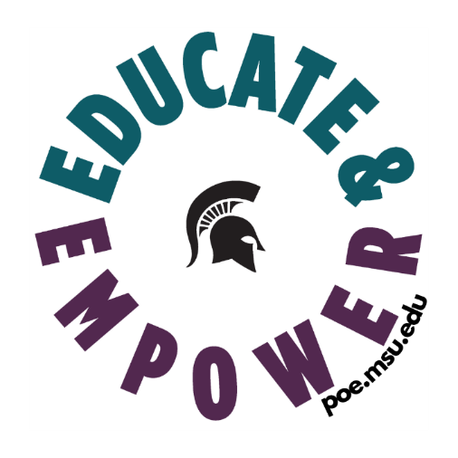
“I am still seeking a career path as rewarding as my time with POE because that experience made me empowered, educated me, and helped me find my voice and passion. It has helped me learn what I do and don’t want in an employer.”

“It helped me realize that I want to spend my time working for companies that help others. It’s great for job experience on a resume but also, it’s an experience that most college students don’t have. It made me more aware of the companies I was applying to and looking into what they do for the world.”

“Diversity, Equity, and Inclusion are top-of-mind in almost every industry. Gender discrimination and sexual harassment and misconduct are a huge part of that. It will take new generations to reset boundaries and expectations around what is and is not acceptable behavior, and the training I got as a POE peer educator helped me build a solid foundation that has led the way for me to be a thought leader in my industry.”

FUTURE GROWTH & DEVELOPMENT
The Prevention, Outreach and Education Department continues to evolve to suit the changing needs of the Michigan State University community. Innovative new initiatives and expansions are planned for the upcoming year. Some highlights include:
(1) MEN'S ENGAGEMENT PROGRAM: POE began its initial plans to develop and execute a men’s engagement program to begin to envision specific ways in which they could utilize men’s or masculine privilege to advocate for gender equity at Michigan State University and beyond. The mission of this program would be to help participants gain greater awareness of the impact of masculinities on their lived experiences and dynamics pertaining to gender-based violence.
(2) EMPOWERMENT SERIES: This year, the Recreational Sports Department transitioned its Self Defense program to the POE department. POE conducted preliminary research with seven various higher education institutions via personal interviews to gain more knowledge and insight about the functions and philosophies of Self Defense programs around the country. Upon reviewing this research, POE plans to develop a Personal Empowerment Series that will include some components of the previous Self Defense program but will largely focus on empowering individuals, rather than solely focusing on physical skills.
(3) NASPA CULTURE OF RESPECT: POE will also be taking a leadership role in the NASPA Culture of Respect Collective. The Collective is a two-year program that utilizes leaders across campus to evaluate, identify gaps and improve systems and departments that support survivors, prevent RVSM and support a campus free of violence.
Sexual Assault & Relationship Violence Prevention Workshop  9,373 | Greeks Take the Lead  2,910 | Graduate Online Training  10,773 | By Request Training  3,972
Bystander Network  8,520 | Spartans Against Violence  781 | Annual Summit  85 | It’s On Us Weeks of Action  500
Undergraduate Online Refresher  15,169 | Employee Online Training  12,167 | Climate & Response  81

64,331
Total Number of individuals trained this year

